Docker Compose
Step 1: Define and run multiple interdependent services
Run:
docker compose up -d
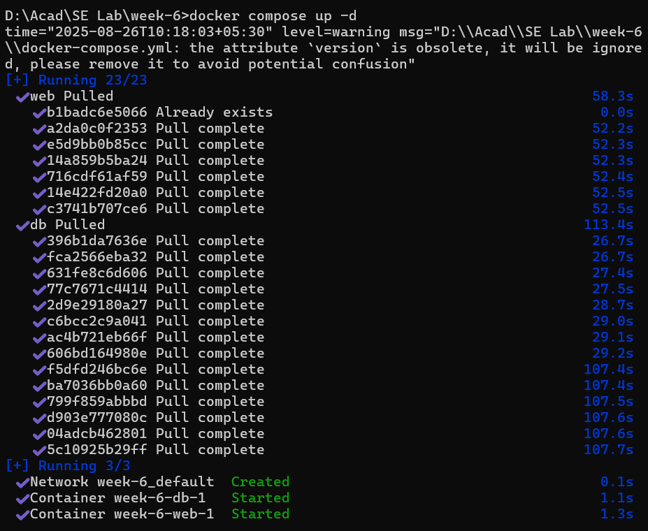
Check services:
docker compose ps
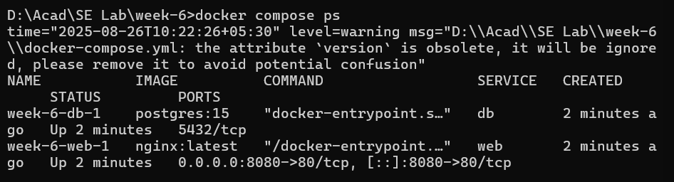
Verify in browser:
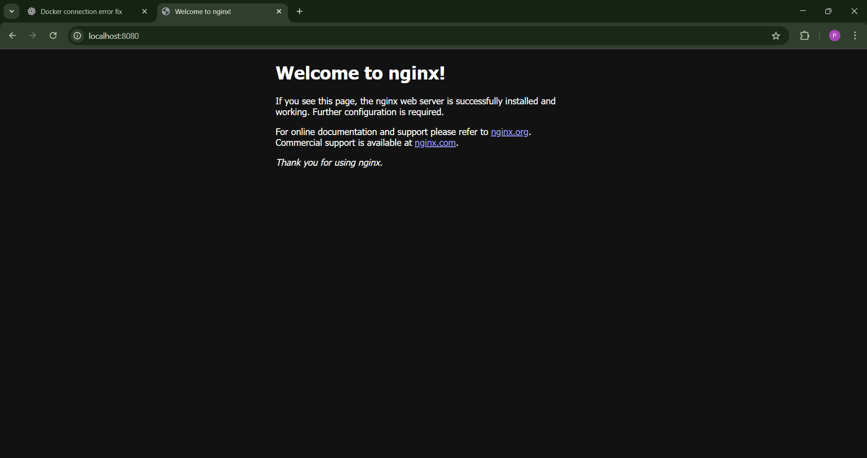
Step 2: Write and interpret docker-compose.yml files
Now add Redis service.
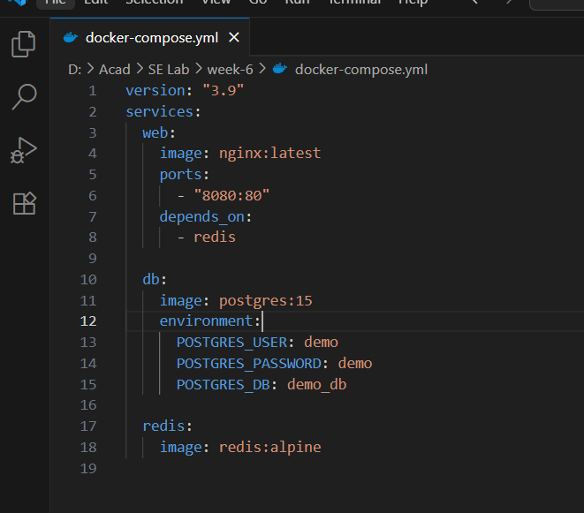
docker compose up -d
docker compose ps
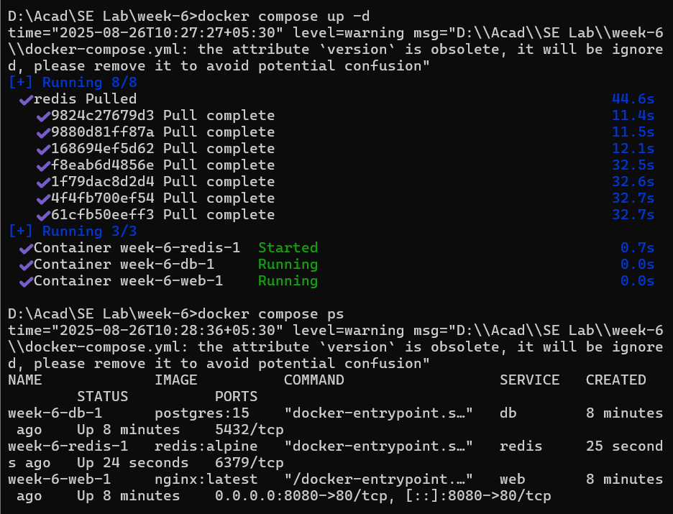
Step 3: Deploy across different machines
Same services are working in another device..
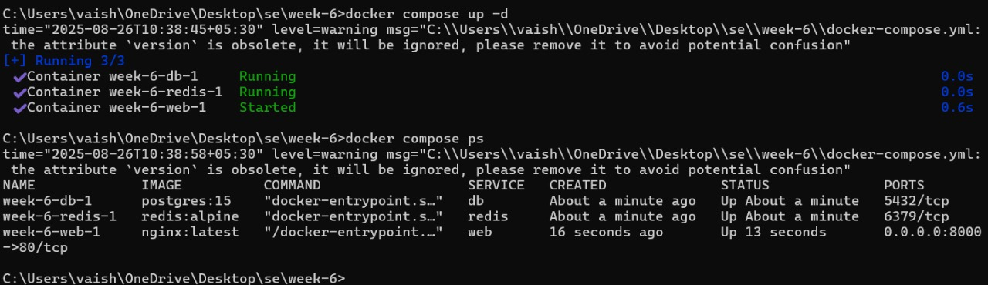
Same web page on another device

Step 4: Networking and persistent storage
Update docker-compose.yml:
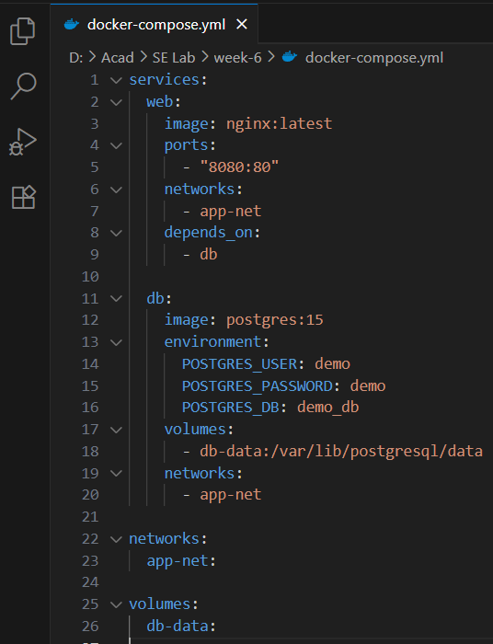
Output:
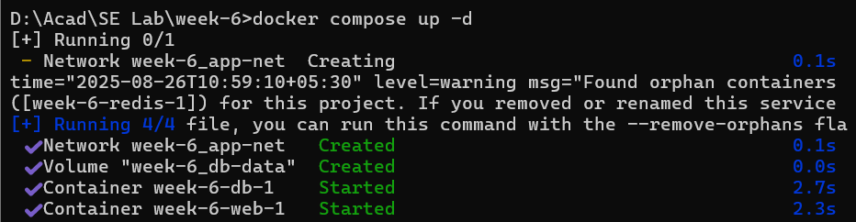
Docker compose ps
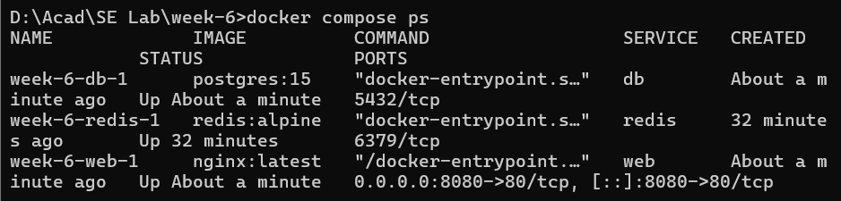
Enter the container:
Run PostgreSQL:
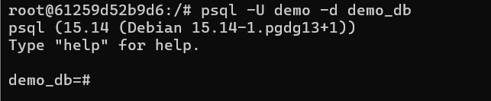
Then create a table and insert data:
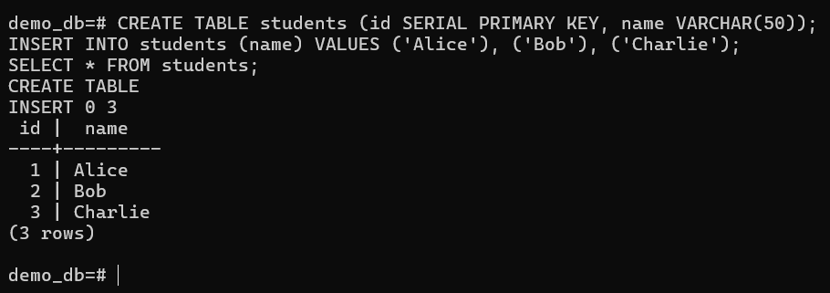
Exit PostgreSQL:

Exit the container:
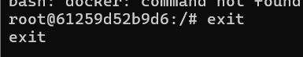
Stop container:
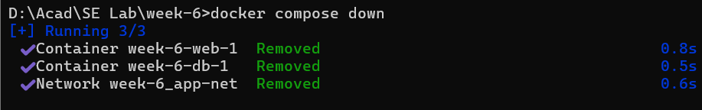
5️⃣ Start containers again
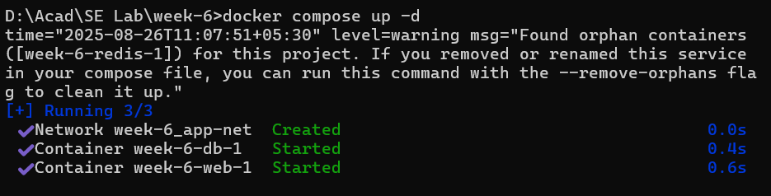
Verify that data is still there:
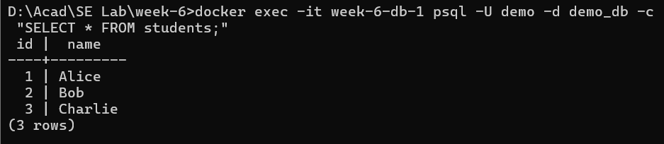
Step 5: Faster Iteration During Development
App.py
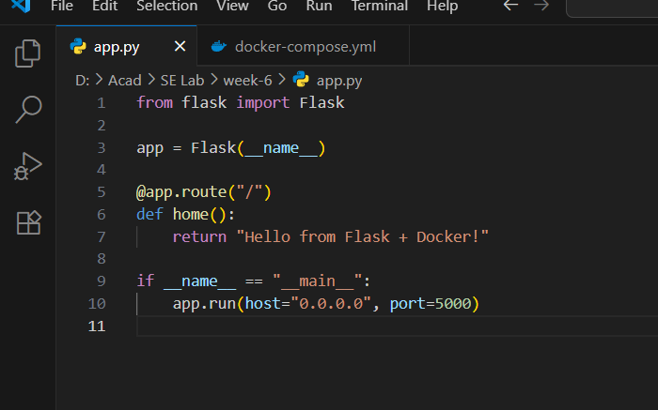
docker-compose.yml
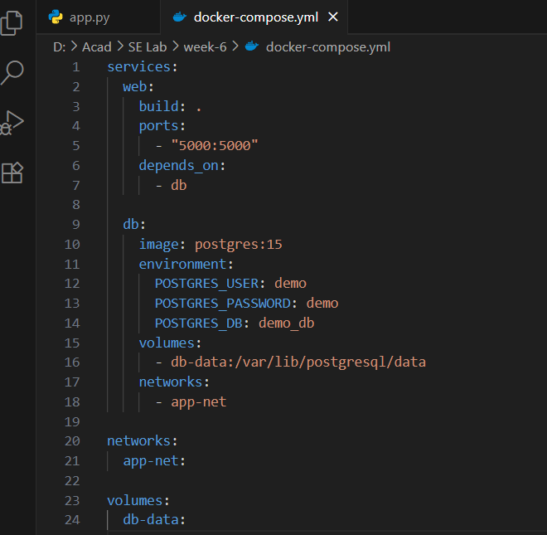
DockerFile
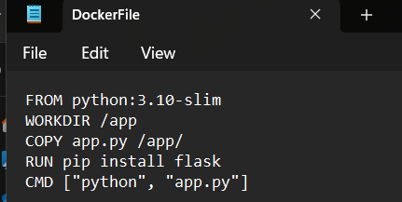
docker compose up –build

Updates app.py
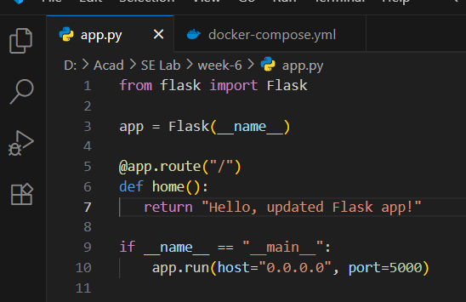
Rebuild & see updated web page:


